**Creating Our First table**

#Create User Table

CREATE TABLE USER_TABLE

(

ID INT PRIMARY KEY,

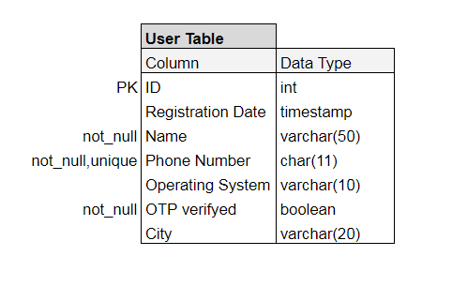REGISTRATION_DATE TIMESTAMP,

NAME VARCHAR(50) NOT NULL,

PHONE_NUMBER CHAR(11) UNIQUE NOT NULL,

OPERATING_SYSTEM VARCHAR(10),

OTP_VERIFYED BOOLEAN NOT NULL,

CITY VARCHAR(20)

);

#ALTER table to add or drop a column or Rename the table

ALTER TABLE USER_TABLE

RENAME TO USER_TAB;

ALTER TABLE USER_TAB

ADD COLUMN GENDER CHAR(1);

ALTER TABLE USER_TAB

DROP COLUMN GENDER;

#Truncate table

TRUNCATE TABLE USER_TAB;

#Drop table

DROP TABLE USER_TAB;

# insert data in our table

INSERT INTO USER_TABLE

VALUES

(1, '2023-10-23 10:00:00', 'John DOE', '1234567890', 'Android', TRUE, 'Dhaka'),

(2, NOW(), 'Jane Smith', '1234567891', 'iOS', FALSE, 'Chittagong'),

(3, CURRENT_TIMESTAMP(), 'Random Name', '1234567892', 'Windows', TRUE, 'Sylhet');

# select / check inserted data

SELECT * FROM USER_TABLE;

SELECT USER_NAME, PHONE_NUMBER FROM USER_TABLE;

# Update data inside the table

## SET SQL_SAFE_UPDATES = 0;

UPDATE USER_TABLE SET OTP_VERIFYED = TRUE;

UPDATE USER_TABLE SET OTP_VERIFYED = FALSE

WHERE USER_NAME = 'John Doe';

#Delete data inside the table

DELETE FROM USER_TABLE

WHERE OTP_VERIFYED = FALSE;

DELETE FROM USER_TABLE;

COMMIT;